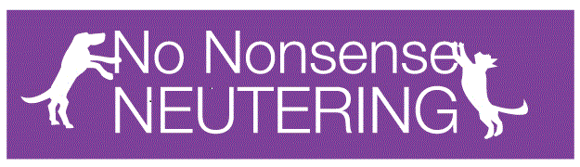
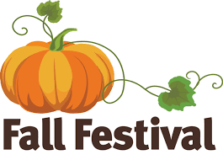
UPCOMING SEPEMBER EVENTS

Come join us for a night of family fun! There will be live music, local shops/vendors, art and craft displays, and children's activities! There will also be craft brews available in the exclusive beer garden! Fun for the entire family. Bring your friends, and family and join us for a night of live entertainment, good food, and fun activities!
Saturday, September 15 at 12:00 PM – 9:00 PM
 | Penn Ave, Reading, PA 19611
- 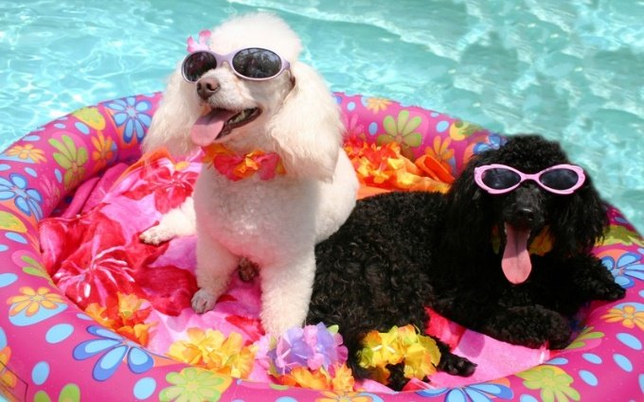 | Pup Pool Party!!  Calling all Water-Loving Dogs! You're invited to a Pup Pool Party! $10 entrance fee (per dog). Benefits No Nonsense Neutering's 18th Ward Community Cats TNR Fund. All people/dog-friendly dogs are welcome! There will be doggy goodie bags, doggy activities, treats, and door prizes! Bring your tail wagging friend and get ready to jump into some fun!  Saturday, September 22 at 1:00 PM – 4:00 PM  Wilshire Pool  Sinking Spring, Pennsylvania 19608  FOLLOW US ON FACEBOOK FOR MORE UPCOMING EVENTS OR VISIT OUR WEBSITE WWW.NNNLV.ORG

